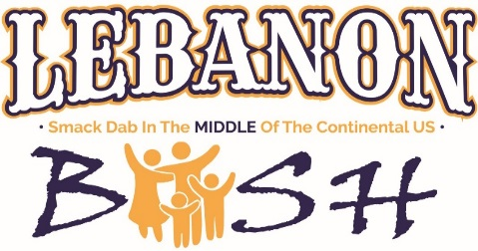
2023 Vendor
Rules & Regulations

DATE: September 9, 2023

LOCATION: Lebanon, Kansas – RAIN OR SHINE

TIME: 10:00 am (Set-up Starts) – 10:30?? pm Saturday, Ready to Serve by 11:00 am

FEE: The Following fees are for the Saturday only time slot per 15X25 booth
Food Vendor with electric/and or water - $50.00
Food Vendor without electric - $25.00

These fees will be refunded upon a successful day/night of arriving and serving.

PAYMENT DEADLINE: August 15, 2023

RULES & REGULATIONS: Booth space is for organization listed only – Serving Trailers are preferred, depending on food types. Set up is as follows; from 8:30-10:00 am Saturday morning. Special Arrangements may be made to set up Friday night. The collection of sales tax is the responsibility of the exhibitor, per requirement of the KS Department of Revenue – Exhibitors must provide their own trash containers, tables, chairs, stands, protections, and extension cords, etc. – Water is not available directly at each booth location, but can be accessible within the area for vendor’s use – All vendors will be in the same general area. Each vendor must clean up their area and leave it as clean as they found it – You must have adult supervision in instances where children who work your booth are under the age of 18 – In the event of inclement weather, no rain provisions will be made.
No rain date will be planned – Please list all of your needs on application such as electricity and what you are powering! Electricity is at a premium and will be available if necessary to operation. Electrical hookup information is required on your form.

All applications are subject to the approval of the committee. Each applicant will be notified of acceptance as soon as possible by email. Please include a current email address on your application form. ANYONE NOT COMPLYING WITH THE POLICIES SET FORTH BY THIS COMMITTEE WILL BE ASKED TO LEAVE AND WILL NOT BE INVITED BACK. No refunds after the August 15th deadline.

Each booth is 15 x 25 with fees listed. Booths will fill up quickly and preference may be given to vendors willing to stay set up throughout all activities. You will be contacted by email once booths are assigned. If you do not have an email, your booth information will be mailed to you.

For additional information, contact us by email at uscenterfoundation@gmail.com or
Jacinta@ruraltel.net
or call/text 785-282-0884

2023 Vendor
Rules & Regulations

Please indicate how many booth spaces you would like in your requested time slot.
With Electric - $50 Time:___________ Without Electric - $25.00 Time:_______

There are a limited number of Electric Spaces and will be issued on a first come, first served basis. Direct water hookups are also limited so make contact early.

Please describe what your booth will be selling._____________________________
______________________________________________________________________

If you need electricity, please list EVERYTHING you are plugging in. ____________________________________________________________________________________________________________________________________________Will you need potable water? ____________Do you use a trailer?_______________

Company Name: ___________________________________________________________

Contact Person: _________________________ __Phone:_____________________

Mailing Address: ___________________________________City: ____________________

State: ______ Zip: ______________

Company Website: _____________________________________________________

Email Address:_________________________

Release of claims: My signature indicates that I have read the information provided in this application and understand it fully, that I, and the organization or business I am representing cannot hold the Lebanon Bash, its Organizing committee, volunteers, and any group affiliated with the Lebanon Bash liable for any incidents, damages, losses, accidents, or thefts that may occur to me, my organization, or business during this event.

____________________________ _________________ Authorized Signature/Printed Name

Return completed application to: U.S. Center Foundation, P.O. Box 24, Lebanon, KS 66952
Please include payment made payable to: U.S. Center Foundation
Applications must be received by August 15, 2019 OR add $10.00 late fee.
Office Use Only - Date Received__________ Approved _________ Paid _________ Lot # __________

