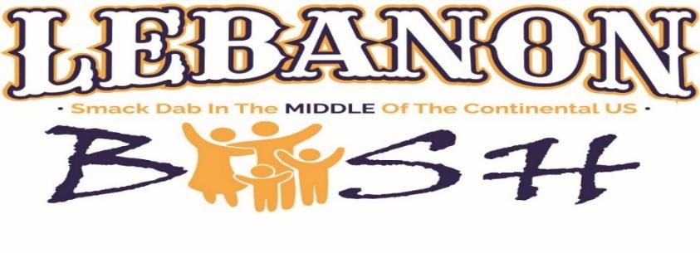

All Welcome September 9, 2023

Sponsorships are welcome anytime. However, in order to improve the advertising exposure for our Lebanon Bash Sponsors, we are requesting sponsorship pledges before August 1, 2023. This will assure our premium advertising opportunities. Invoices, wristbands and meal vouchers will be mailed in August.

SPONSORSHIP FORM
TITANIUM LEBANON BASH SPONSOR
______ $2,500 to be a part of “The BIG Five”
Premier recognition distinguishes your company as an Official Sponsor for the Lebanon Bash. Banners/signage advertising your company/logo displayed on Main Street at the Bash and throughout the venue, including the Concert Area;
Plus,
- Repeat recognition during radio advertising;
- Name/brand recognition on all Lebanon Bash print media advertisements, posters to be displayed throughout our 2-state region (Kansas and Nebraska).
- Featured and media content on the Lebanon Bash Facebook page & Website: www.LebanonBash.com;
- Recognition during announcements throughout the day of the Bash;
- Premium, large logo placement on the official Lebanon Bash T-shirts.
- Included, you will receive Twelve (12) Wristbands to the concert; Twelve (12) $5 Meal Vouchers.
- In addition, Five (5) 3’x5’ banners (or equivalent signage) listing company logo/information displayed at the Bash. “The BIG Five” presents an opportunity for five businesses to partner and stake their claim as the Official Sponsors of the Bash. All recognition remains the same but ad space/time will be shared with the partnering companies. Each business will be awarded the same ticket amounts as indicated above.

______$1,000 PLATINUM SPONSOR
- Recognition at the Lebanon Bash and recorded advertising spots;
- Name recognition on Bash print advertising and posters throughout the Kansas/Nebraska region;
- Recognition on programs the day of the Bash;
- Recognition on the Lebanon Bash Facebook page and premium business name placement on the official Lebanon Bash T-shirts;
- Six (6) Wristbands to the concert; and Six (6) $5 Meal Vouchers.
- Two (2) 3’x5’ banners (or equivalent signage) listing company logo/information displayed at the festival. Event exclusivity is available on a first come first serve basis for PLATINUM SPONSORS and provides the opportunity for your name to be tied with a specific event during the Lebanon Bash and all advertisement for that event. If exclusivity is desired, please rank on the list below, your desired events from 1-5.

______ TRAP SHOOT SPONSOR
Banners/signage displayed at the Trap Shoot and Main St. with your company name/logo.

______ BIG BASH KIDS FISHING TOURNAMENT SPONSOR
Banners/signage displayed at the Pond and Main St. with your company name/logo.

______ SANCTIONED KIDS PEDAL POWER PULL SPONSOR
Banners/signage displayed at the Pedal Pull on Main St. with your company name/logo.

______ CLIMBING WALL & INFLATABLES SPONSOR
Banners/signage displayed at Climbing Wall and Main St. with your company name/logo.

______ YARD GAMES SPONSOR
Banners/signage displayed at the Corn Hole Games and Main St. with your company name/logo.

______ U.S. CENTER CAR SHOW SPONSOR
Banners/signage displayed at the Car Show on Main St. with your company name/logo.

______ PONY RIDES SPONSOR
Banners/signage displayed at the Pony Rides on Main St. with your company name/logo.

______ KIDS & ADULTS ARCHERY SPONSOR
Banners/signage displayed at the Archery setup and on Main St. with your company name/logo.

______ U.S. CENTER GOLF TOURNAMENT SPONSOR (Held Sunday Morning after cleanup)
Banners/signage displayed at the Golf Tournament and on Main St. on Saturday, Sept. 9th.

$ ______ Gold Sponsor - $500-$999
Recognition on announcements the day of the Bash; Enhanced Recognition on our Facebook Page & Website; Two (2) Wristbands to the Concert; and Two (2) $5 Meal Vouchers. PLUS, One (1) 3’x5’ banner listing company logo/information displayed at the festival.

$ ______ Silver Sponsor - $250-$499
Recognition on announcements the day of the Bash; Recognition online; Two (2) Wristbands to the Concert; PLUS One (1) 2’x2’ banner listing company logo/information displayed at the festival.

$ ______ Bronze Sponsor - $100-$249
Recognition on programs the day of the Bash; Recognition online; One (1) Wristbands to the Concert. Ability to provide One (1) Bash Approved Banner (2’ x 2’) to be displayed at the Bash; to be brought by Friday, Sept. 8th.

Looking for additional ways or In-Kind Sponsorships to build brand loyalty? Contact us!

uscenterfoundation@gmail.com OR call: 785-620-7115 for any questions. Leave message.

**U.S. Center Foundation reserves the right to add, modify, or omit package benefits.

Company Name: __________________________________________________________

Mailing Address: ___________________________________City: ___________________

State: ______ Zip: ______________

Company Website: _________________________________________________________

Contact Person for Branding/Logo: ____________________________________________

Phone Number: _______________________ Email Address: ________________________

____________________________ _________________ Authorized Signature/Printed Name

You will be contacted to obtain digital copies of your artwork and how you officially want your business to be recognized in our publications.

________ Or, please, use our previous company logo.

**Please make checks payable to: U.S. Center Foundation; P.O. Box 24; Lebanon, KS 66952

NOTE: Any contributions are welcome. All contributors will be named during various announcements the day of the festival and online. Certificates of Contributions will be mailed.

